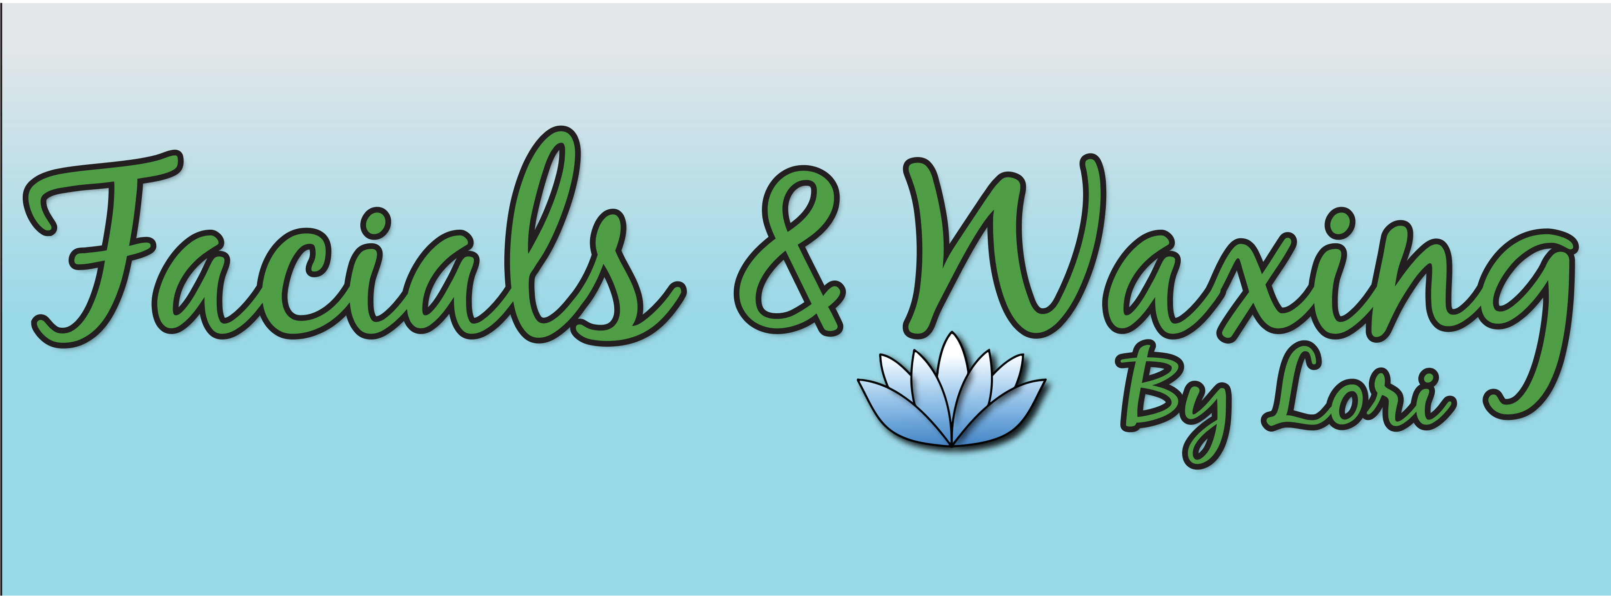
Name: ___________________________________Date of Birth:_______________________
Address:____________________________________________________________________
Home Phone: ________________________Cell Phone:_____________________________
E-mail address:___________________________Referredby:__________________________
Emergency Contact: (Name &Phone)_____________________________________________
What would you like to achieve from your treatment today?________________________
Do we have permission to show your photos for educational purposes/social media? ____Yes ____No
Your Skin Care
1) Have you ever had a facial treatment before? __ No __ Yes, when? ________________
2) Which of the following best describes your skin type? (Please circle one type number)
I Creamy complexion Always burns easily, never tans II Light Complexion Always burns, tans slightly III Light/Matte Complexion Burns moderately, tans gradually IV Matte Complexion Seldom burns, always tans well V Brown Complexion Rarely burns, deep tan VI Black Complexion Never burns, deeply pigmented
3) Do you have any special skin problems or concerns pertaining to your face or body?    __Yes __ No specify:_______________________________________________________
4) Have you ever had chemical peels, laser or microdermabrasion? __ No __ Yes In the last month?  __No __Yes
5) Have you used any of the following hair removal methods in the past six weeks? __ No__ Yes, circle all that apply.
Shaving Waxing Electrolysis Plucking Tweezing Stringing Depilatories
6) Do you use Retin-A, Renova, Adapalene Hydroxyl Acid or Retinol/vitamin A derivative products?  __No __Yes describe:________________________________ 7) What SPF do you use on your face?____________ How often/when? _____________
8) What areas of concern do you have regarding your: Skin: (Please check any that apply and explain)
Breakouts/acne___ Uneven skin tone___ Blackheads/whiteheads___ Sun damage/Wrinkles/fine lines ___ Excessive oil/shine___ Redness/ruddiness___ Rosacea___ Dull/dry skin/Flaky skin___ Broken capillaries___ Dehydrated___ Sun spot/liver spot/brown spot___ Other: ______________
Eyes: dehydrated __ wrinkles __  puffiness __  darkcircles  __ Other: ______________ Lips: dehydrated __ cracked/chapped lips__  Other: ______________
9) Have you ever had a skin allergic reaction? If yes, please explain: ___________________________________________________________________________
10) Have you experienced Botox, Restylane, or Collagen injection? __No __Yes ,If yes When was the last injection._________ Female Clients Only: 11) Are you taking oral contraceptives?  __No  __Yes 12) Are you pregnant or trying to become pregnant? __No __Yes 13) Are you lactating?  __No  __Yes 14) Any menopause problems?  __No __Yes specify:______________________________ 15) Are you undergoing any hormone replacement therapy?  __No __Yes
Male Clients Only: 16) What is your current shaving system? Wet shave __  Electric __
17) Do you experience irritation from shaving?__No __Yes   Ingrown hairs? __No __Yes
I understand, have read and completed this questionnaire truthfully. I agree that this constitutes full disclosure, and that it supersedes any previous verbal or written disclosures. I understand that withholding information or providing misinformation may result in contraindications and/or irritation to the skin from treatments received. The treatments I receive here are voluntary and I release this institution and/or skin care professional from liability and assume full responsibility thereof.
Client Signature: _________________________________________Date:______________
Please read carefully and initial the following:
_____ I understand that Facial and Waxing by Lori services including facials and body treatments given at Facials and Waxing by Lori, are for the sole purpose of skin cleansing, body and mind relaxation and rejuvenation.
_____ I understand that it is imperative to tell my Esthetician about any oral or topical medications prior to any facial, waxing, or body treatment services.
_____ I understand that Facials and Waxing by Lori do not diagnose illness, disease, or any other physical or mental disorder. I accept full responsibility of the use of Facials and Waxing by Lori at my own risk, and to not hold Facials and Waxing by Lori liable for loss, damage, or injury.
_____ I understand that results are personable and not guaranteed.
_____ I confirm that to the best of my knowledge that the answers given on client consultation form are correct and that I have not withheld any information that maybe relevant to my treatment at Facials and Waxing by Lori.
_____ I understand that I must provide at least 24 hours advance notice for the cancellation of an appointment.
_____ I understand Facials and Waxing by Lori has a strict 24 hour cancellation policy. In the event of a late cancellation/no show the fee of 50% of the scheduled value. The credit card to book the appointment will be charged. If we can reschedule your appointment, we will be happy to waive the fee.
_____ I understand there are risks associated with skincare treatments. Such as: redness, sensitivity, peeling, and inflammation. Any additional concerns I will discuss with my practitioner.
*Please note any additional information that may be of importance to your Licensed Esthetician regarding the spa treatment you will be receiving:

Signed by Client_____________________________________ Date__________________

